MFA v2 Beta Test 09/23/26
Tester: baumanj-America

- Can you access the MFA repository? https://github.com/DNRFISH/MFA
# install.packages("remotes")
remotes::install_github("DNRFISH/MFA")

- The above code works.
- YES – This took about 10 minutes or so to load everything.

- Using the code on the README (on repository main landing page), can you install MFA and run all the example code?

library(MFA)

con <- FISHub_connect()

- The above code works.
Querying FISHub

FISH_query() retrieves survey, effort, or catch data from FISHub.
For example, to retrieve Status & Trends surveys from 2025:

surveys <- FISH_query(
con,
QueryType = "Survey",
SurveyPurpose = "Status & Trends",
Year = 2025
)
- The above codes works. That said, there are some warnings:
- Warning messages:
- 1: In FISH_query(con, QueryType = "Survey", SurveyPurpose = "Status & Trends", :
- DO NOT USE THESE DATA UNTIL VERIFIED!!!

- The following SurveyIDs were identified with catch discrepancies:

- 330
- 152

- See data(Catch_discrepancies) for reference. Contact MFA team for more information.

- WARNED YOU HAVE BEEN
- 2: In FISH_query(con, QueryType = "Survey", SurveyPurpose = "Status & Trends", :
- The following SurveyIDs were identified as S&T surveys with extra (non S&T) efforts:

- 347
- 252

- DO NOT USE as part of S&T surveys. Use SurveyPurpose='Status & Trends' to filter out.
- See data(Status_and_Trends_extra_efforts) for reference. Contact MFA team for more information.
- Data are listed in a table with 70 obs. Of 9 variables.
To retrieve effort data for a specific survey:
- I am choosing to review data from SurveyID 157 (Round Lake), instead of 805.
efforts <- FISH_query(
con,
QueryType = "Efforts",
SurveyId = 157
)

- The above code works.
- Effort data are listed in a table with 40 obs. and 20 variables.
- **Enhancement** - There is value providing MFA the code to produce an “Effort Summary”. Rather than 40 rows, there are rows for each gear type used and a column to represent the total effort for that gear type. An effort summary table like this would be useful for survey reports. Also, being able to compare effort summary table information across other calculation pages would help to build trust in MFA. In other words, if total effort by gear type values are consistent across outputs, users will be more likely to ‘trust’/use the software.

Catch data can also be filtered by survey, species, gear, waterbody, or other available criteria:

catch <- FISH_query(
con,
QueryType = "Catch",
SurveyId = 157,
GearType = "SMFYKE"
)

Note: query only returns surveys/efforts that had the specified gears.

- The above code works. Data are listed in a table with 14 obs. and 28 variables.
- Additional code was run to test GearType = “BOOMSHK” and “LMFYKE”. Both worked. I could not do all gears at once, probably because I was not coding it properly.

Catch by effort
catchByEffort() summarizes catch associated with individual sampling efforts and includes information such as total catch, average length, minimum and maximum length, and legal-sized catch where applicable.

catch_by_effort <- catchByEffort(
con = con,
effortData = efforts
)

- The above code works. But I might be confused by the output. There were 144 obs. and 10 variables created. I am assuming this is catch by effort data for LMFYKE, but I am not sure based on the table created (titled “catch_by_effort”).

CPUE
CPUE_byGear() summarizes catch per unit effort by sampling gear. OutputTypes include "Table" or "Figure"

cpue <- CPUE_byGear(
catchData=catch,
OutputType="Table"
)
CPUE_byGear(
catchData=catch,
OutputType="Figure"
)
- The above code works. I did this for LMFYKE data. Both the table and figure populated accordingly.
  - FIGURE: Can/Should we standardize text in accordance with ADA or American Fisheries Society or MDNR report writing standards? I am not sure what the current font style/size is, but if we aren’t able to modify that text prior to inputting in a survey report, that might be an issue later down the road. Issue might be 1) its not ADA compliant, and 2) Different text style and size in the figures might result in inconsistent text within a survey report or Status of the Fishery Resource Report. This is may not be a high priority. Many biologists are likely to create their own graphs/figures using the raw data provided in the tables.

Age-length summaries
- ageLengthSummary() summarizes age-length information and can return "RawData", "Table", or "Figure".

age_length_raw <- ageLengthSummary(
con = con,
effortData = efforts,
OutputType = "RawData"
)
- The above code worked. 268 obs. and 6 variables.

# Return summary statistics
age_length_table <- ageLengthSummary(
con = con,
effortData = effortData,
OutputType = "Table"
)
- The above code did NOT work. Changed “effortData = effortData” to “effortData = efforts” per C. Boon’s suggestion and it worked. Recommend editing the README code.

age_length_table <- ageLengthSummary(
con = con,
effortData = efforts,
OutputType = "Table"
)
- The above code worked. 37 obs. of 9 variables.

# Create a length-at-age figure
ageLengthSummary(
con = con,
effortData = effortData,
OutputType = "Figure"
)
- The above code did NOT work. Changed “effortData = effortData” to “effortData = efforts” per C. Boon’s suggestion and it worked. Recommend editing the README code.

# Create a length-at-age figure
ageLengthSummary(
con = con,
effortData = efforts,
OutputType = "Figure"
)
- The above code worked (see output below). Biologists should be aware that these figures are drawn even when less than 5 age structures are available. Should we code this differently to be able to show the graph when only 5 or more structures are available? Also, some users might prefer standard error versus standard deviation. In my opinion, it doesn’t matter. Just know that some users are most familiar with summary tables using standard error, similar to what is shown in Wehrly et al. 2015. Last, the “0.5” added to the age makes biological sense…but I could see some folks requesting that these ages be rounded down to the nearest year in age.
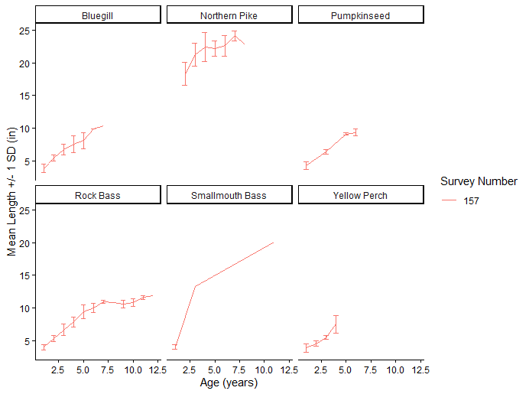

Detection by year
detectionByYear() produces a table that summarizes which years a given species has been detected.

# Query catch data for a waterbody
catchData <- FISH_query(
con,
QueryType = "Catch",
WaterBodyName = "Lake Orion"
)
- The above code works.

# Create a yearly detection summary
detection_summary <- detectionByYear(catchData)
- The above code works. These summaries are useful. I see them used most often in Status of the Fishery Resource Reports (Tonnello and Cwalinksi use them often). However, the abundance of ‘blank’ cells make these tables unsuitable for Status of the Fishery Resource Reports. Therefore, users should know that using these tables in Status of the Fishery Resources Reports may not be appropriate. I wonder if there was another way to show these data without so many blanks….Or, if the data were portrayed as a ‘complex map or figure’ we might be able to avoid ADA flags with alternative text.

Length frequency
- lengthFreqByEffort() summarizes length-frequency information by survey, sampling module, species, and inch group.

length_frequency <- lengthFreqByEffort(
con = con,
effortData = efforts
)
- The above code works.

lengthFreqByEffort(
con = con,
effortData = efforts,
OutputType = "Figure"
)
- The above code works. I’m not sure this Figure will provide users much, unless it can be tailored a bit. For example, users are going to want to remove certain species (e.g., forage fishes, less represented species). See below: The only species of value for reporting in figure might be Common shiner and Bluegill. Also, it appears that the figure jumped a cell, so some standardization of cell number and column number might be needed. I don’t see a lot of value in this figure from a report writing standpoint. But it is a good visualization for users to be able to glance at.
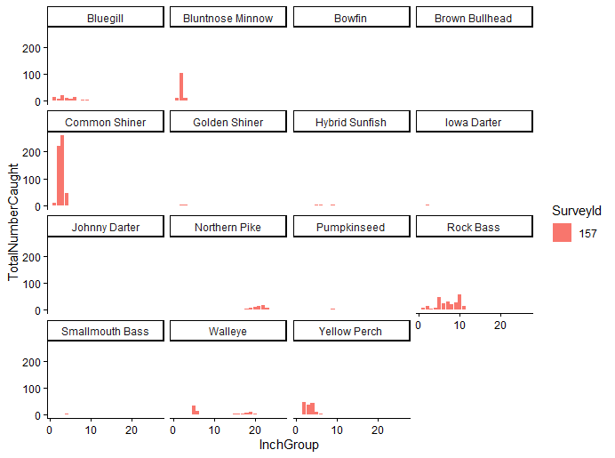

Relative stock density
RSD() calculates relative stock density using Gabelhouse length categories.

rsd <- RSD(length_frequency)
- The above code works.
  - There is a lot that I like about relative stock density data. As an example, I think these data and the summaries that MFA will be able to provide will become very useful as our Centrarchidae committee gets going. We could screen lakes to find those with a suitable RSDs that might highlight lakes as good candidates for new/trophy panfish regulations, etc..
  - There are also a few things I don’t like about these RSD tables.
    - Calculations for RSD, PSD, etc., are mixed or different among users and sometimes they’re just wrong. So, I think it will be useful to have these calculations done by MFA. While most people can look at the numbers and reverse engineer to see how calculations are conducted, some wont. I think it would be valuable to have a code source available so people can see how these calculations are done.
      - This is really nitpicky on my part: The terminology is not consistent with how the data are portrayed. For example, all values are expressed as a percent, but “proportional stock density” is not really a percent, nor is it a density.
      - **Enhancement** Based on the community composition of the lake, can we incorporate Predator:Prey plots that provide more depth to this information? An output figure that automatically shows the proportion of LMB:BLG for example.

